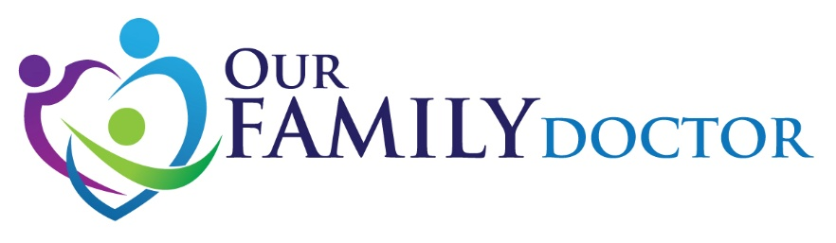

In partnership with Manna Foodbank, and in advance of the Holiday Season,
OFD is holding a Food Drive !
October 19th – November 20th
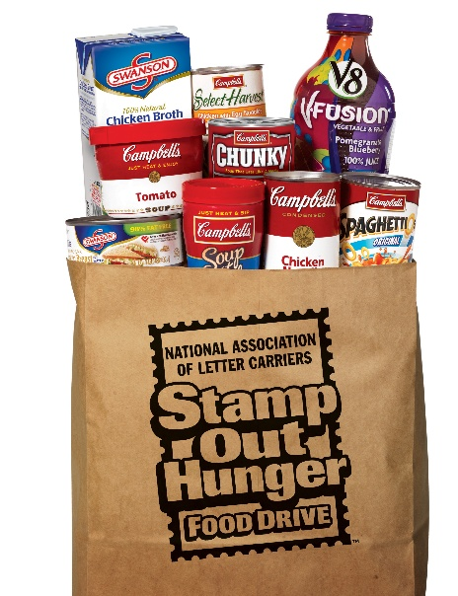

Please consider bringing non-perishable food items, and unopened toiletries to OFD during your next visit or when next in the neighborhood.

Let’s work together to support the WNC community!

